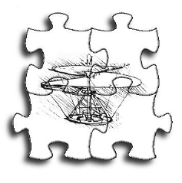
Training &
Support
Technology
Report Number: TST05I030, Rev. A
Issue Date: 14 February 2006

Inspiration, Innovation & Integration

Software Design Document
for the
CIGI Host Emulator
Version 3.1.x

The Boeing Company
Training and Support Technology
Research and Development

PREPARED BY:
Lance W. Durham
Software Engineer

APPROVED BY:
Carl Vorst
Principal Investigator –Visualization

APPROVED BY:
Willard B. Phelps
Manager – Training Devices IRAD



LIST OF PAGES

Title Page
ii through 5
1 through 34

TABLE OF CONTENTS
Paragraph Page
1. Scope 1
2. Purpose 1
3. Background 1
4. Application Overview 1
4.1 Main (Win32) Process 1
4.2 Driver 2
5. Architecture 3
5.1 Inter-Process Communication 3
5.1.1 Events 3
5.1.2 Mutexes 4
5.1.3 Messages 4
5.1.3.1 Shared Message Queues 4
5.1.3.2 Message Types 5
5.2 Data Sharing 10
5.2.1 CSharedEntityObj 12
5.2.2 CSharedViewObj 15
5.2.3 CSharedViewGroupObj 17
5.3 CIGI Message Management 18
5.4 Main Process 18
5.4.1 Data Manager 19
5.4.2 Shared Objects 19
5.4.2.1 CEntity 19
5.4.2.2 CCigiView 20
5.4.2.3 CViewGroup 20
5.4.3 Configuration Templates 20
5.4.4 Script Processor 21
5.5 Driver 21
5.5.1 Threads 21
5.5.2 Main Loop 23
5.5.3 Buffered Record and Playback 25
5.5.4 RTX API Façade 26
6. Abandoned Designs 27
6.1 Unsynchronized Data Access 27
6.2 Asynchronous Object Creation and Write 27
7. Acronyms 29

TABLE OF FIGURES
Figure Page

Figure 1. Shared Buffer Queue Class Design 5
Figure 2. HEMU_MESSAGE Base Class 6
Figure 3. Shared Object Base Class Design 11
Figure 4. CSharedEntityObj UML Diagram 13
Figure 5. The ENTITY Datatype 14
Figure 6. CSharedViewObj UML Diagram 15
Figure 7. The VIEW Datatype 16
Figure 8. CSharedViewGroupObj UML Diagram 17
Figure 9. The VIEWGROUP Datatype 18
Figure 10. Driver Thread Sequence Diagram 22
Figure 11. Send/Receive Thread Sequence Diagram 24

TABLE OF TABLES
Tables Page

Table 1. Event Kernel Objects 3
Table 2. Win32-to-Driver Messages 6
Table 3. Driver-to-Win32 Messages 8
Table 4. Win32-to-Win32 Reflexive Messages 9
Table 5. Driver Thread Priorities 23

TABLE OF LISTINGS
Listings Page

Listing 1. Compare-And-Set (CAS) Routine 12
Listing 2. Example Script with Implicit Waits 28

Scope
This document describes the main design elements and, where significant development effort has been spent, a few critical implementation details of the CIGI Host Emulator, as well as lessons learned.

Purpose
The purpose of this document is to capture the main design elements of the Host Emulator. The document’s primary focus is the higher-level architectural aspects. However, where significant development effort has been spent on overcoming problems or improving performance, these implementation details are described more thoroughly. Unsuccessful design approaches and lessons learned are also discussed.
Note that as CIGI is currently undergoing standardization and maturation activities, the Host Emulator will necessarily evolve with the interface specification. The architecture of the program will likely evolve as well. This document will be updated as needed to reflect design changes to the Host Emulator.

Background
The Common Image Generator Interface (CIGI) is an open-standard data interface between a simulation host device and an Image Generator. Boeing originally developed CIGI and currently plays an active role in its maturation and standardization activities. In an effort to promote CIGI as an industry standard and to improve interoperability of CIGI-capable devices, Boeing has released its CIGI tools to the Open Source community. The CIGI Host Emulator is one of these tools.

Application Overview
The Host Emulator is a development and test tool for implementing the CIGI interface. Capabilities of the Host Emulator include free-flight, scripting, record and playback of CIGI messages, and a packet-level snoop feature.
Two major versions of the Host Emulator exist. Version 2.x uses the CIGI 2 standard; Version 3.x uses version 3 of the standard. Substantial architectural differences exist between Versions 2.x and 3.x of the Host Emulator. This document focuses on Version 3.x.
The Host Emulator runs as two processes. These are a main application process and a driver. These are introduced below and are described in more detail in Section 5.

Main (Win32) Process
The main process runs within the Win32 subsystem and provides the user interface and performs most file I/O. This process is responsible for the following:
- Providing the Graphical User Interface (GUI) for the system
- Loading CIGI entity, terrain, and view configurations from definition (.def) files
- Loading/saving network configuration from/to the Windows Registry
- Loading/saving the simulation state to scenario (.sf3) files
- Loading and executing script (.scp) files
- Reading the joystick state
- Calculating relative waypoint positions
The main process is based on Version 6.0 of the MFC application framework. In addition to providing the main application loop and the Windows message pump, MFC provides for mapping of events, synchronization of threads, serialization of objects (file I/O), and other application-level tasks. MFC also provides views and other windows, controls (widgets), data collection classes, thread synchronization objects, and other useful datatypes. MFC works well with the Win32 API, the Windows Multimedia API, DirectX, GDI, and other Windows-specific programming interfaces.

Driver
When the main process starts, it will spawn an instance of the driver program. The driver handles calculations of motion, network I/O, and file I/O during record and playback.
The driver is built on RTX by Ardence. RTX is a hard real-time extension to Windows. Information about RTX can be found on the Ardence web site (http://www.ardence.com).
A Win32-only version of the driver can also be built. A façade API has been created to translate the RTX API calls to Win32. See Section 5.5.3 for more information on this façade.
For the RTX version of the Host Emulator, the driver runs as an RTSS (Real-Time Subsystem) process within the RTX environment. For the Windows version of the Host Emulator, the driver runs within the Win32 subsystem. In the latter case, if the Host Emulator detects multiple CPUs it will elevate the priority of the driver to improve determinism.

Architecture
The Host Emulator is a test application designed to be used with high-end image generator (IG) devices. In order to truly test IG performance, such a test tool must be deterministic and must not introduce performance inconsistencies of its own.
Because of the performance requirements of the test tool, and because the Host Emulator was developed for the Windows operating system, the Host Emulator’s core is built upon the RTX real-time extensions for Windows. RTX installs a dedicated execution environment called RTSS in which real-time processes run without interference from the Windows kernel. Inter-process communication (IPC) between Win32 and RTSS processes can be accomplished through shared data, events, mutexes, and semaphores.
RTX alone is not suitable for fully interactive programs. RTX provides no mechanisms for graphical output or input from a mouse or keyboard. Access to other system components and devices is limited, was well. The inner workings of the Host Emulator, therefore, are divided among two processes: a main process that provides the GUI and interfaces with DirectX and other system components, and a driver that performs time-critical tasks such as motion calculations and network I/O in a real-time manner.
This section describes the main architectural features of the main process and driver, including the IPC and data-sharing mechanisms between the two processes. Also discussed is the rationale behind the implementation of CIGI message management.

Inter-Process Communication
Inter-process communication (IPC) between the main process and driver is implemented through kernel-mode events and mutexes and shared, thread-safe message queues.

Events
Event kernel objects are used to communicate events between the driver’s threads. These events are summarized in the following table:
Table 1. Event Kernel Objects
Event | Description
StartShutdown | This event is signaled by either the Send/Receive thread or the WaitForWin32ToDie thread when the driver should terminate. The Shutdown thread waits indefinitely for this event, and when the event is signaled, released all objects and begins its cleanup procedures.
EndShutdown | This event is signaled by the Shutdown thread after all objects are released. The driver’s Main thread then releases this event and terminates.
StartRecordShutdown
EndRecordShutdown
ReceivedMessage

Note that the StartRecordShutdown and EndRecordShutdown events are used for both recording and playback. This is acceptable because execution of the Record and Read threads is mutually exclusive. In fact, both event objects were originally intended to be used with both threads; however, the word “Playback” was omitted from the event names to keep them short.

Mutexes
A single mutex object, Win32ProcDiedMutex, is shared between the driver and Win32 processes at the application level. This mutex owned by the Win32 process and is used by the driver to detect when the Win32 process is terminated abnormally. If this occurs, the mutex will be orphaned. A high-priority thread in the driver (WaitForWin32ProcToDie) will then be released and will signal a StartShutdown event. The driver will then shut down normally. Refer to 5.5.1 for further details.
Mutexes are also used by the shared message queues as described in Section 5.1.3.1 below.

Messages
Events are useful for notifying one or more threads when something has occurred; however, the only information inherent to an event object is the signaled state of that object. Any additional information must be communicated via some other mechanism. Messages are used by the Host Emulator to fill this need.

Shared Message Queues
The Host Emulator uses two shared, thread-safe inter-process message queues. One queue is reserved for messages to the main process; only the main thread of this process retrieves messages from this queue. The other queue is reserved for messages to the driver, and only the Send/Receive thread retrieves messages from this queue. Any thread in either process may enqueue (post) messages to either queue.
The message queues are instances of a class called RTXSharedBufferQ. This class encapsulates a circular array of buffer pointers and a circular array of corresponding buffer sizes. The following illustration shows the class structure:
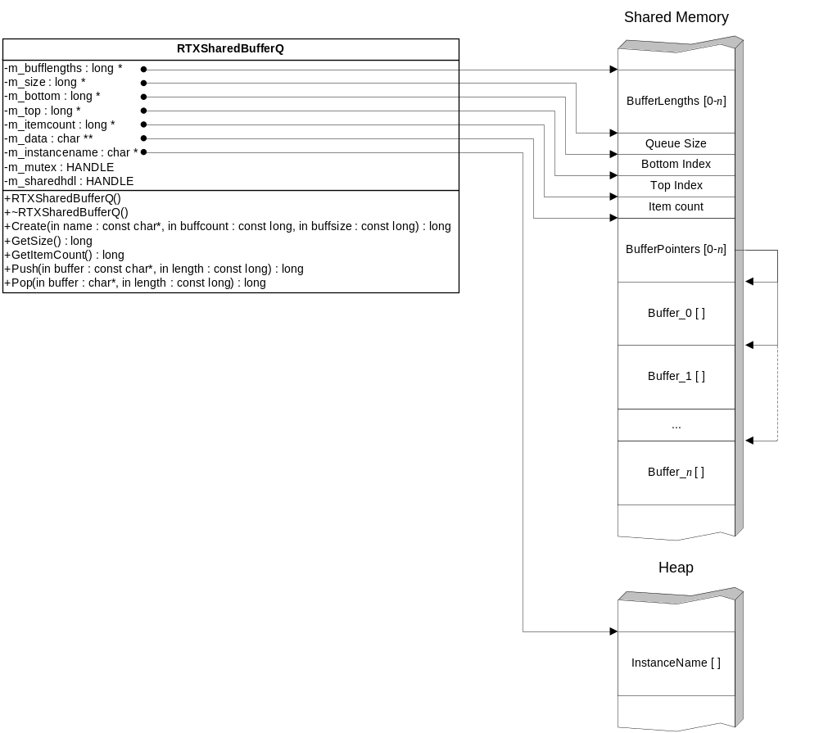
Figure 1. Shared Buffer Queue Class Design
All data members of the RTXSharedBufferQ class are either handles or pointers to class data. With the exception of the instance name, which is stored on the heap, the class data themselves are stored in shared memory. These include an array of buffer lengths, the size of the queue, bottom and top indices into the buffer array, the number of items in the array, a vector of pointers into the array of buffers, and the actual array of buffers.
Shared memory is reference-counted and uses handles for allocation and de-allocation operations. The m_sharedhdl member variable is the handle to the object’s shared memory block.
The m_mutex member variable is the handle to the object’s mutex object. This mutex controls access to the queue, making the queue thread-safe.

Message Types
All message objects used by the Host Emulator derive from the abstract HEMU_MESSAGE class. The following illustration shows a UML representation of the HEMU_MESSAGE base class:
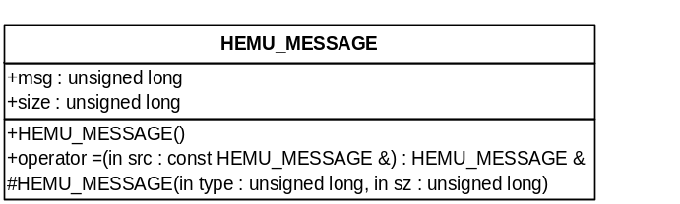
Figure 2. HEMU_MESSAGE Base Class
The first two data members in every message object are the message type ID (msg) and the size of the message in bytes. The default constructor is public to allow for creation of temporary objects. The parameterized version of the constructor is protected and is only called by derived classes during instantiation. An assignment operator is also implemented in the base class and will work on any two instances of the same derived type.
All of the derived message types may be categorized by sender and receiver. Win32-to-Driver messages are sent from the main (Win32) process to the driver. Driver-to-Win32 messages are sent from the driver to the main process. Finally, Win32-to-Win32 messages are passed reflexively within the Win32 process.
Table 2 lists the Win32-to-Driver messages and describes the use of each. These messages are posted from the main process whenever it needs to change the internal state of the driver or invoke a driver-controlled action.
Table 2. Win32-to-Driver Messages
Message Name | Action
MESSAGE_ADD_ENTITY | The driver will create an entity object that references a named shared data structure. The driver will add the address of the new object to the entity list.
MESSAGE_DEL_ENTITY | The driver will remove the pointer to the entity object from the entity list and call the object’s destructor. The destructor will close the handle to the shared data structure, decrementing its reference counter.
MESSAGE_CLEAR_ENTITIES | The driver will empty the entity list and call the destructor for each entity object.
MESSAGE_ADD_VIEW | The driver will create a view object that references a named shared data structure. The driver will add the address of the new object to the view list.
MESSAGE_DEL_VIEW | The driver will remove the pointer to the view object from the view list and call the object’s destructor. The destructor will close the handle to the shared data structure, decrementing its reference counter.
MESSAGE_CLEAR_VIEWS | The driver will empty the view list and call the destructor for each view object.
MESSAGE_ADD_VIEWGROUP | The driver will create a view group object that references a named shared data structure. The driver will add the address of the new object to the view group list.
MESSAGE_DEL_VIEWGROUP | The driver will remove the pointer to the view group object from the view group list and call the object’s destructor. The destructor will close the handle to the shared data structure, decrementing its reference counter.
MESSAGE_CLEAR_VIEWGROUPS | The driver will empty the view group list and call the destructor for each view group object.
MESSAGE_RUN_EXERCISE | The driver will set its RunState flag.
MESSAGE_PAUSE_EXERCISE | The driver will clear its RunState flag.
MESSAGE_RESET_HOST | The driver will clear its RunState flag. The main process currently resets the state of the scenario.
MESSAGE_RESET_IG | The driver will set the IG Mode parameter of the IG Control packet to Standby/Reset.
MESSAGE_SHUTDOWN | The driver will set the IG Mode parameter of the IG Control packet to Standby/Reset and signal the “Begin Shutdown” event.
MESSAGE_SET_ADDR | The driver will close all sockets and reinitialize all network connections with the specified IP address and port numbers.
MESSAGE_ADD_HAT | The driver will add a new HAT/HOT object to the HAT/HOT list.
MESSAGE_REMOVE_HAT | The driver will remove the HAT/HOT object from the HAT/HOT list.
MESSAGE_ADD_LOS | The driver will add a new LOS object to the LOS list.
MESSAGE_REMOVE_LOS | The driver will remove the LOS object from the LOS list.
MESSAGE_BEGIN_RECORD | The driver will open a file for writing and create a low-priority Record (write) thread. The thread will write all buffered outbound CIGI messages to the file.
MESSAGE_END_RECORD | The driver will signal a “Begin Record/Playback Stop” event and wait for an “End Record/Playback Stop” event. When the “End Record/Playback Stop” event is signaled, the driver will close the file.
MESSAGE_BEGIN_PLAYBACK | The driver will open a file for reading, create a low-priority Playback (read) thread, and set the OperateMode flag to MODE_PLAYBACK.
MESSAGE_END_PLAYBACK | The driver will signal a “Begin Record/Playback Stop” event. When the Playback thread detects this event, the thread will close the file and terminate.
MESSAGE_PAUSE_RECPLAYBACK | The driver will set the PauseRecPlaybackState flag.
MESSAGE_RESUME_RECPLAYBACK | The driver will clear the PauseRecPlaybackState flag.
MESSAGE_SET_DATABASE | The driver will clear the RunState flag and will move the entities to the new database. Each entity will retain its position relative to the database origin.
MESSAGE_SET_TRACKER_STATE | The driver will send a Motion Tracker Control packet to the IG specifying the state of the tracker. This functionality is not yet implemented.
MESSAGE_SET_TRACKER_BORESIGHT | The driver will send a Motion Tracker Control packet to the IG specifying the boresight state of the tracker. This functionality is not yet implemented.
MESSAGE_SET_IG_MODE | The driver will set the IG Mode parameter of the IG Control packet.
MESSAGE_SET_HUD_STATE | The driver will enable or disable outgoing HUD data. The HUD is turned off during compile time by default and may be enabled by defining the WITH_HUD preprocessor symbol. The HUD_DATA structure may be tailored to fit a given application.
MESSATE_SET_BYTE_ORDER | The driver will set or clear the BigEndian flag. When this flag is set, the Host Emulator will byte-swap outbound CIGI messages to simulate a big-endian platform.

Note that the driver will repost a message back to the same queue if the object referenced by that message is locked (see Section 5.2). This provides a built-in try-retry mechanism that allows the driver to be non-blocking.
Table 3 lists the Driver-to-Win32 messages. These messages are posted whenever the driver needs to notify the main process of some event or error condition or to force the GUI to be updated.
Table 3. Driver-to-Win32 Messages
Message Name | Description
MESSAGE_PLAYBACK_EOF | This indicates that the end of file has been reached during playback.
MESSAGE_FILE_ERROR | This indicates that the specified Record or Playback file cannot be opened.
MESSAGE_FRAME_RATE | This is sent periodically to indicate the current average data rate of the IG.
MESSAGE_NO_CONNECT | This is sent periodically when no data is received from an IG.
MESSAGE_MISSILE_HIT | This notifies the main process when a missile hits its target.
MESSAGE_NOTIFY_ANIM_STOP | This notifies the main process when the driver receives an Animation Stop Notification packet from the IG.
MESSAGE_NOTIFY_CAPTURE_FRAME | This signals the end of a frame while the driver is recording outbound CIGI messages. The main process uses this notification to present record progress information to the user.
MESSAGE_WAYPOINT_REACHED | This notifies the main process when an entity has reached a waypoint.
MESSAGE_UPDATE_ENV_VIEW | This forces the GUI to update the Environmental Properties view.
MESSAGE_UPDATE_ENTITIES_VIEW | This forces the GUI to update the Entity Properties view.
MESSAGE_UPDATE_VIEWS_VIEW | This forces the GUI to update the View Properties view.
MESSAGE_UPDATE_ENV_TAB_PAGES | This forces the GUI to update the tabbed property pages on the Environmental Properties view.
MESSAGE_UPDATE_ENTITY_TAB_PAGES | This forces the GUI to update the tabbed property pages on the Entity Properties view.
MESSAGE_UPDATE_VIEW_TAB_PAGES | This forces the GUI to update the tabbed property pages on the View Properties view.

Table 4 lists the reflexive Win32-to-Wn32 messages. These are sent and processed internally within the main process. This mechanism allows certain actions to be performed asynchronously and provides a method of internal communication between threads. These messages are useful for changing the states of widgets, timers, and other non-thread-safe objects.
Table 4. Win32-to-Win32 Reflexive Messages
Message Name | Description
MESSAGE_SCRIPT_EOF | This notifies the main thread when the end of the script file has been reached.
MESSAGE_SCRIPT_PROGRESS | This is sent periodically from the script processor thread to the main thread to indicate which line number within the script file is currently being executed.
MESSAGE_DISPLAY_MSG_TEXT | This causes the main thread to output a character string to the Messages window in the GUI. The Messages window provides textual information to the user.
MESSAGE_SCRIPT_LOAD_SCENARIO | This is sent to the main thread whenever a script specifies that a scenario file is to be loaded.
MESSAGE_SCRIPT_SAVE_SCENARIO | This is sent to the main thread whenever a script specifies that the simulation state should be saved to a file.
MESSAGE_SCRIPT_RELOAD_SCENARIO | This is sent to the main thread whenever a script specifies that the scenario should be reset to its saved state.
MESSAGE_SCRIPT_CAPTURE_PLAY | This is sent to the main thread whenever a script commands playback of a capture file.
MESSAGE_CLEAR_MSG_TEXT | This causes the main thread to clear the Messages window in the GUI.
MESSAGE_UPDATE_DATABASE | This causes the main thread to update the Database toolbar.
MESSAGE_SPAWN_APP | The causes the main thread to spawn a new process.
MESSAGE_SCRIPT_BEGIN_WAIT_TIMER | This causes the main thread to create a timer object and to reset the timer indicator in the Script window.
MESSAGE_SCRIPT_INC_WAIT_TIMER | This causes the main thread to update the timer indicator in the Script window.
MESSAGE_SCRIPT_END_WAIT_TIMER | This causes the main thread stop the script wait timer and update the timer indicator in the Script window.
MESSAGE_SCRIPT_ADD_ENTITY_TO_GUI | This causes the main thread to add an entity to the necessary GUI widgets. This is sent by the script thread after a new entity is created.
MESSAGE_SCRIPT_DEL_ENTITY_FROM_GUI | This causes the main thread to delete an entity from the necessary GUI widgets. This is sent by the script thread when an entity is destroyed.
MESSAGE_SCRIPT_SET_PARENT_IN_GUI | This causes the main thread to update the GUI widgets when an entity’s parent has changed.
MESSAGE_SCRIPT_SET_VIEWGROUP_IN_GUI | This causes the main thread to update the GUI widgets when a view’s group assignment has changed.
MESSAGE_SCRIPT_SET_PAUSE | This causes the main thread to set the state of the Pause button on the Script window.

Data access to the queue is protected by a mutex. The timeout period for this mutex is 1ms, which is the smallest timeout period allowed by the Win32 and RTX APIs. This timeout period means that the driver will wait at most 1ms for the queue resource to be released. If, however, the Win32 process is preempted before it can complete the enqueue operation, then the driver’s message will never be posted.
Note: An asynchronous message post operation will be incorporated into the driver in a future release.

Data Sharing
Entity, view, and view group state data are shared between the main process and driver. For RTX builds, the shared data structures are contained in non-paged kernel memory. This prevents paging operations in Windows from affecting RTX performance. For Win32 builds, the shared data structures are contained in a memory-mapped region of the system swap file.
Although an object’s data storage is shared, each process has its own address space and maps to the shared memory at a different logical address. Each instance of the object, therefore, must store its own pointer to the data. No object data are stored within the object itself.
All shared data objects are lockable. A shared object can be made lockable by performing a compare-and-set operation on a member variable used as a lock flag. When a thread needs to write to a data object, it performs a get-and-lock operation. After the thread writes to the data, it must perform an unlock operation.
Because the driver requires real-time or near-real-time performance, the driver has been designed to be wait-free. This means that the driver is able to achieve progress even if an object is locked. If the driver attempts to obtain a lock on an object that is currently locked, the driver will queue the object and retry after all other objects of that type have been processed. The driver will then retry until the object becomes unlocked. Real-world use has shown that in all likelihood an object will be released by the second or third attempt.
Unlike the driver, the main process does not require real-time performance and is not wait-free. If the main process attempts to lock an object that is currently locked, the process will sleep until the object is released. Because the driver never locks an object for more than a few microseconds, there should be no noticeable impact to the user.
The following diagram illustrates the design of the base class:
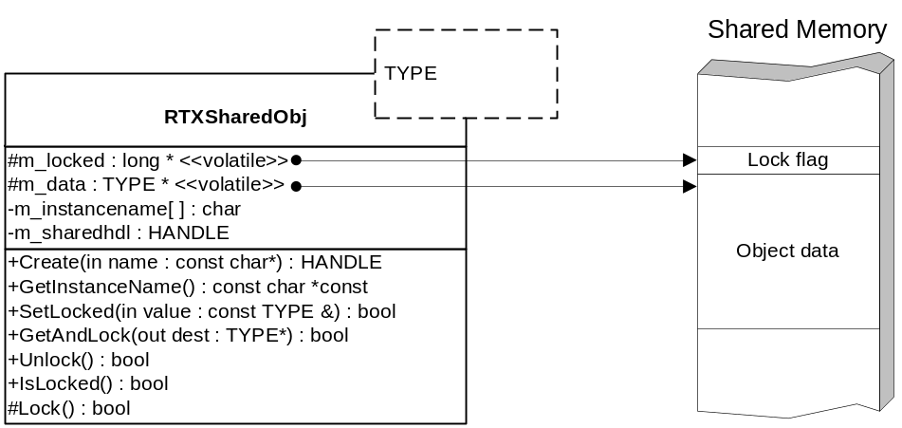
Figure 3. Shared Object Base Class Design
The lock and unlock operations are atomic. In other words, the processor guarantees that once a thread checks the lock state, no other thread can execute until the first thread has set the new lock state. This means that a thread cannot be preempted even by the operating system during the check-lock operation. This behavior is made possible by the Pentium’s cmpxchg instruction. This instruction provides an atomic compare-and-exchange operation and locks the memory bus while the instruction is in the processor’s pipeline.
Neither C nor C++ provides a standard compare-and-exchange function, so a short assembly routine must provide this functionality. Because the old flag state does not need to be returned by the function, a compare-and-set routine is sufficient. Further, a Boolean return value from a compare-and-set operation is conceptually easier to use than the return value of a compare-and-exchange operation. Such a routine is shown in the figure below. Note that the inline assembly feature of Microsoft Visual C++ is used and that the assembly code has visibility to the variables declared in the C/C++ code above it.
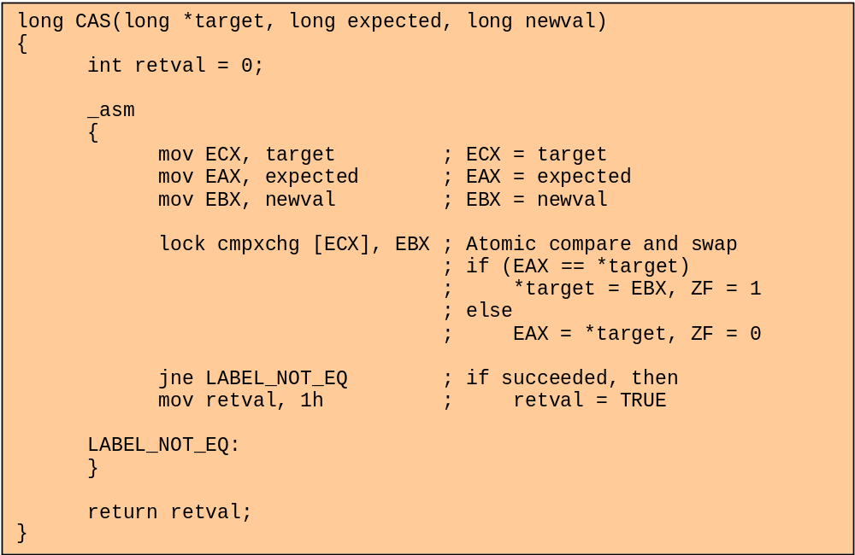
Listing 1. Compare-And-Set (CAS) Routine
CAS() takes three arguments: a pointer target to an integer (in this case the lock flag), an expected value expected, and a new value newval. If the value pointed to by target matches the value of expected, then the integer pointed to by target is assigned the value newval and CAS() returns TRUE. If the value pointed to by target does not match the value of expected, then CAS() returns FALSE.
The shared object base class provides only one member accessor function, GetAndLock(), to retrieve a copy of the object’s data. GetAndLock() calls CAS(), passing in the address of the lock flag along with the expected value (0) and new value (1) for the flag. If CAS() returns TRUE, GetAndLock() retrieves a copy of the shared data structure and returns TRUE. If CAS() returns FALSE, then GetAndLock() will return FALSE.
Unfortunately, this mechanism can cause a deadlock if the same thread attempts to obtain a second lock on the object. The program, therefore, must be designed in such a way that no thread will attempt a lock on a locked object. Future enhancements to the shared object class might replace the lock flag with a thread handle (or NULL if not locked) and add a lock count member variable. Subsequent calls to GetAndLock() could increment the lock count as long as the thread handle remains the same. More research is needed to determine if this is an acceptable approach, as successive calls to GetAndLock() might return stale data.
Three classes derive from specializations of RTXSharedObj<>. These class types are described below.

CSharedEntityObj
The CSharedEntityObj class derives from RTXSharedObj<ENTITY> as shown in the UML diagram below:
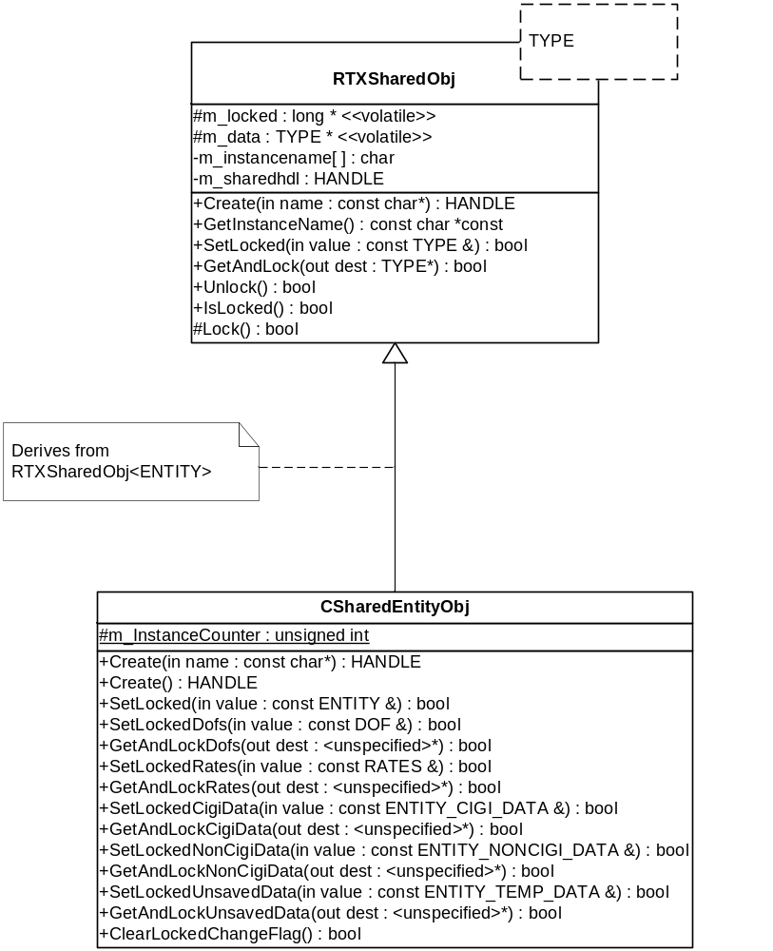
Figure 4. CSharedEntityObj UML Diagram
The ENTITY datatype is a struct that contains all entity state data that are needed by both the main process and the driver. ENTITY divides these data into three groups. The first group comprises the ENTITY_CIGI_DATA structure. These attributes correspond to parameters in the CIGI Entity Control packet. When an attribute contained within ENTITY_CIGI_DATA changes, the Host Emulator should send a new Entity Control packet to the IG. Note that the data in ENTITY_CIGI_DATA are persistent; on other words, the contents of this structure are saved to a scenario file.
The ENTITY_NONCIGI_DATA structure contains the second group of ENTITY attributes. This structure contains persistent, non-CIGI data. These are crucial attributes such as entity class, flight model, airspeed, etc., that describe entity behavior. These attributes are not, however, included in the Host-to-IG interface.
Finally, the ENTITY_TEMP_DATA structure contains the third group of attributes. These data are transient (not saved to a file) and are not part of the Host-to-IG interface. These data include waypoint information, values for integrating rotations and velocities over time, data-changed flags, and other information of a temporary nature.
Figure 5 shows a UML representation of the ENTITY datatype:
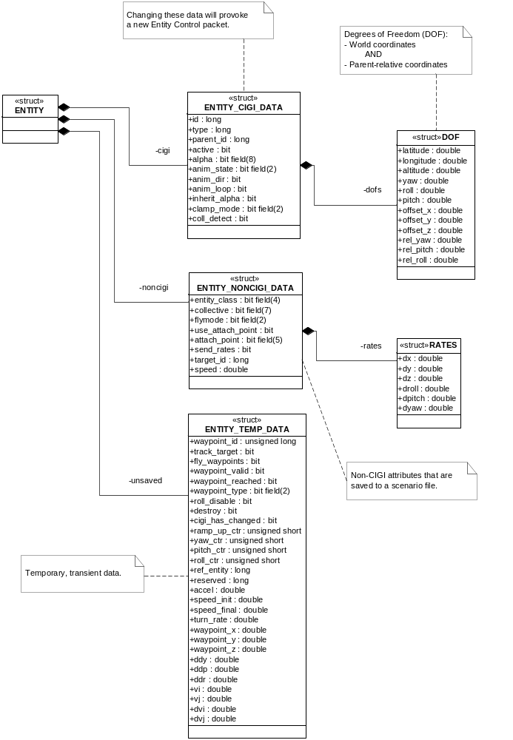
Figure 5. The ENTITY Datatype
CSharedEntityObj extends the set of accessor functions by providing a pair of accessors to each of the nested child structures. This allows smaller, more closely related groups of data to be updated rather than the entire ENTITY structure. This is more efficient and more convenient to the programmer.
Note that ENTITY_TEMP_DATA structure contains a cigi_has_changed member. This member is set whenever one or more data within ENTITY::ENTITY_CIGI_DATA have changed. This tells the driver that a new Entity Control packet should be generated for the entity. CSharedEntityObj provides a method called ClearLockedChangFlag() that clears the cigi_has_changed in a single function call. The function fails if the object is not locked.

CSharedViewObj
CSharedViewObj derives from RTXSharedObj<VIEW>. This relationship is shown in Figure 6.
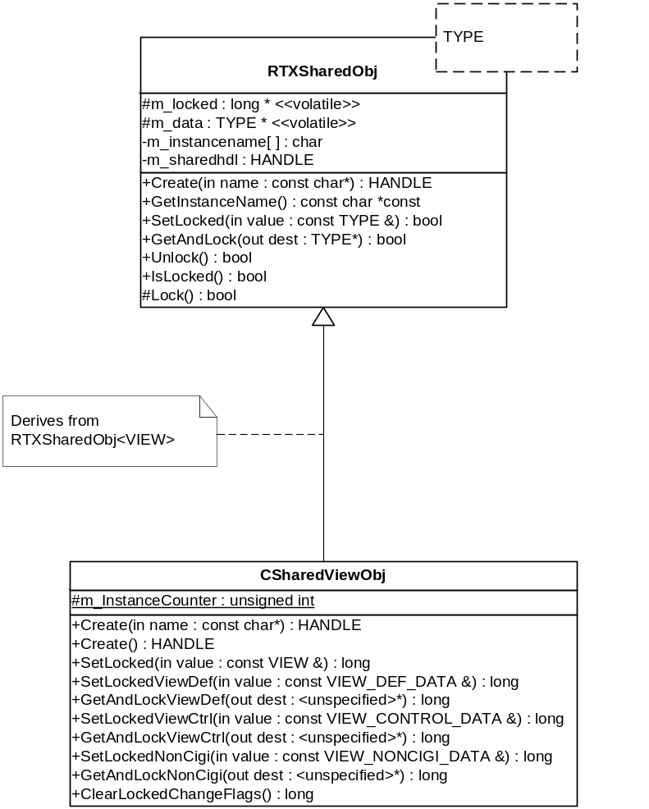
Figure 6. CSharedViewObj UML Diagram
The VIEW datatype is composed of three child structures. The viewdef member is of type VIEW_DEF_DATA and contains data that are contained within the CIGI View Definition packet. The viewctrl member is of type VIEW_CONTROL_DATA and contains data that are in the View Control packet. Changes to either of these member structures should cause the driver to send one of these two CIGI packets. Finally, the noncigi member, a VIEW_NONCIGI_DATA structure, contains data that are not represented in CIGI. CSharedViewObj implements individual accessor functions for each of these members.
The VIEW structure is modeled in Figure 7.
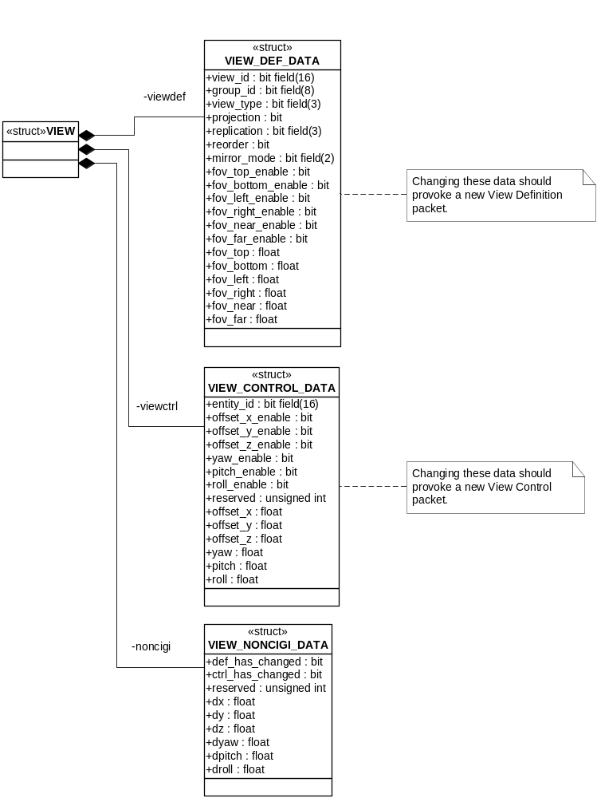
Figure 7. The VIEW Datatype
The VIEW_NONCIGI_DATA structure contains two flags to indicate when CIGI data have been changed. The def_has_changed flag is set when one or more elements of the VIEW_DEF_DATA structure have changed, and the ctrl_has_changed flag is set when the VIEW_CONTROL_DATA structure has been changed.
CSharedViewObj provides a method called ClearLockedChangeFlags() that clears both flags in a single function call. The function fails if the object is not locked.

CSharedViewGroupObj
The CSharedViewGroupObj class derives from RTXSharedObj<VIEWGROUP>. This relationship is shown in Figure 8.
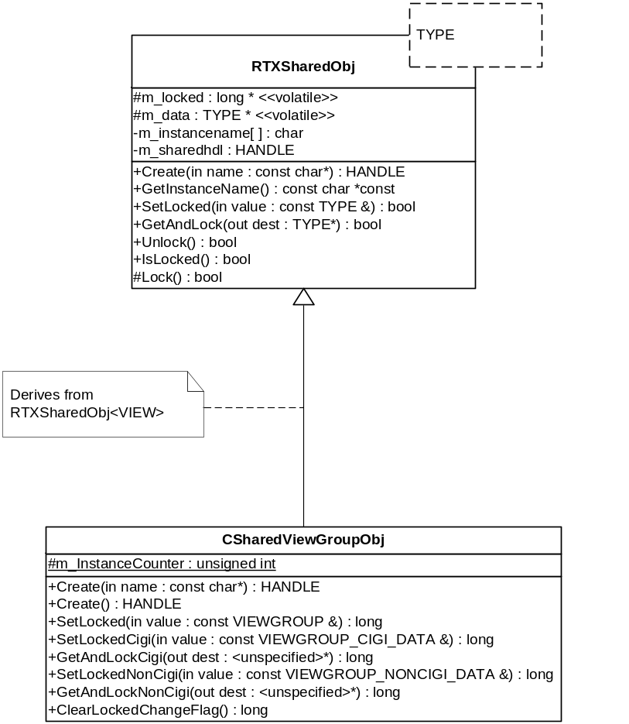
Figure 8. CSharedViewGroupObj UML Diagram
Like ENTITY and VIEW, VIEWGROUP is a composite datatype made up of child structures representing CIGI and non-CIGI data. These data members are called cigi and noncigi and are of the types VIEWGROUP_CIGI_DATA and VIEWGROUP_NONCIGI_DATA, respectively. Changes to the cigi member should cause the driver to send a View Control packet to the IG.
The VIEWGROUP datatype is modeled below in Figure 9.
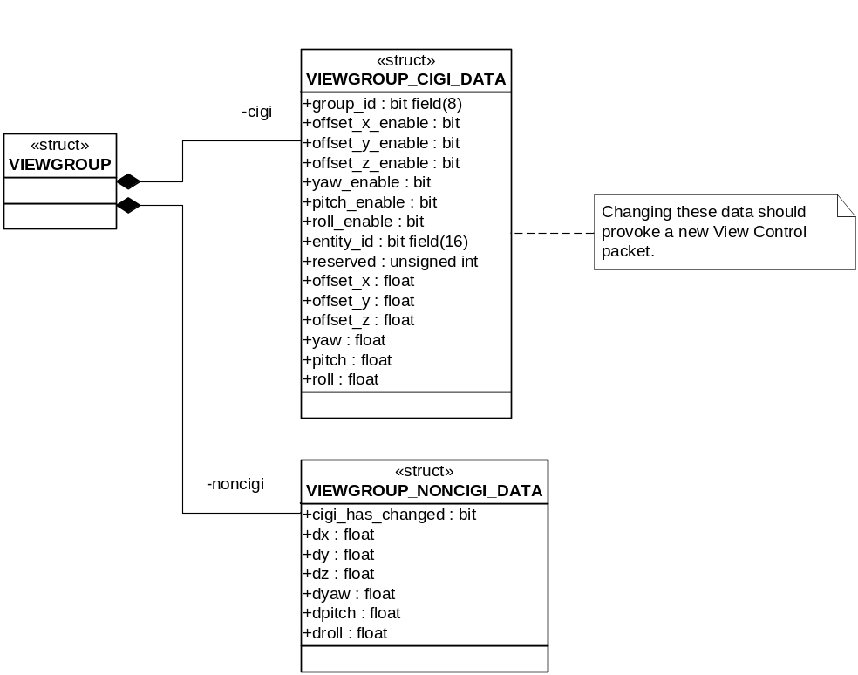
Figure 9. The VIEWGROUP Datatype
The cigi_has_changed flag within VIEWGROUP_NONCIGI_DATA indicates that the VIEGROUP’s cigi member has been modified. This flag can be cleared by calling CSharedViewGroupObj::ClearLockedChangeFlag().

CIGI Message Management
Version 2 of the Host Emulator used the CIGI API. With the release of CIGI 3.0, the API was replaced with the CIGI Class Library (CCL). For development of Version 3 of the Host Emulator, the CIGI API code was modified to support CIGI 3.x and was incorporated into the Host Emulator’s source code distribution. This was done because the Host Emulator was used in development and testing of the CCL. This provided a non-recursive test platform for the CCL.
Refer to the CIGI API Users’ Guide (http://cigi.sourceforge.net/manual/index.html) for details on the internal design of the API.
Note: The modified CIGI API code will be replaced with the CCL in a future release of the Host Emulator.

Main Process
The main process runs within the Win32 subsystem. This process handles all user interaction and performs file I/O for loading configuration settings and for scripting. The main process also interfaces with any additional system devices, components, and resources.
The paragraphs below describe the mechanisms used to load definition (configuration) files and to execute scripts.

Data Manager
The Data Manager is a centralized repository for all of the Host Emulator’s simulation data. It stores all shared objects, configuration data, terrain attributes, environmental weather properties, waypoints, HAT/HOT and LOS objects, system components, and IG events. The Data Manager object controls construction and destruction of these items, provides access to each, and performs serialization.
The Data Manager also performs certain updates to the GUI as necessary when objects’ states are changed, although this functionality will be moved outside the class in a future version of the Host Emulator.

Shared Objects
Entity, view, and view group data are stored in shared memory and are protected by the CSharedEntityObj, CSharedViewObj, and CSharedViewGroupObj classes, respectively. Within the main process, these objects are further abstracted through the CEntity, CCigiView, and CViewGroup classes, each of which encapsulates the corresponding shared memory class.
These higher-level classes are described below.

CEntity
CEntity provides the interface for all entity operations within the Win32 main program. This class derives from MFC’s CObject and overrides Serialize(). The default constructor is only used during serialization and is therefore protected.
CEntity encapsulates CSharedEntityObj as well as articulated parts, components, mission function objects, weather attributes, and waypoints. CEntity also contains the entity name and MFC control (widget) item handles and iterators for interfacing with the GUI.
CEntity provides accessor methods for most of the data contained within ENTITY. These accessors call the CSharedEntityObj::GetAndLock(). If the shared data are already locked, the accessor will sleep briefly and retry until the new lock can be obtained. In this way, the main process is blocking.
CEntity also contains a non-shared instance of the ENTITY_CIGI_DATA and ENTITY_NONCIGI_DATA structures. These members contain the initial state of the entity. When the user manually updates the entity’s state through the GUI, or when the entity state is loaded from a scenario (.sf3) file, these initial state structures are updated. When the scenario is reset, the shared data are populated from the structures. CEntity provides accessor methods for both structure-wise and member-wise reads and writes.
Because the driver does not need to update components and articulated parts in real-time, these objects are not part of the ENTITY structure. They are, however, associated with a particular entity and are therefore stored in CEntity. Attachment points, HAT/HOT and LOS objects, and collision detection objects are treated similarly. These objects are all stored in specializations of MFC’s CMap<> template class. CEntity exposes member functions to handle creation, deletion, and retrieval of these objects.
Waypoints are stored in a specialization of the CTSQueue<> (thread-safe queue) template class. CEntity provides member functions to add waypoints that are defined either in absolute (Geodetic) or relative positions.
When the program calls CEntity::FlyWaypoints(), the first waypoint is popped from the queue and placed in the shared ENTITY::ENTITY_TEMP_DATA structure. The fly_waypoints and waypoint_valid flags in that structure are set at this time, as well. The driver will calculate the new position closer to the waypoint each frame until the entity comes within a certain range; then, the driver will clear the waypoint_valid flag and post a MESSAGE_WAYPOINT_REACHED message to the main process. Note that the waypoint_reached flag in the ENTITY_TEMP_DATA structure is also set; however, the main process no longer checks this flag.
The GetWeatherAttributes() member function returns a WEATHER structure containing weather-specific attributes for weather entities.
The GetLaunchAnimList(), GetPersistentLaunchAnimList(), and GetDetonationAnimList() methods return linked lists (specializations of MFC’s CList<> template class) containing entity IDs of child animations for missile entities.
The ApplyTemplate() member function is used to build the entity from a configuration template. All entity attributes are initialized and default values are loaded from the template. Components, articulated parts, collision detection volumes and segments, and attachment points are also created from the template.

CCigiView
CCigiView provides the interface for all CIGI viewport operations within the main program. Note that the name CCigiView is used because CView is already defined within the global namespace by MFC.
Like CEntity, CCigiView derives from MFC’s CObject and overrides Serialize(). The default constructor is only used during serialization and is therefore protected.
CCigiView encapsulates CSharedViewObj. Accessor methods are provided to allow protected access to most of the data contained within the VIEW structure. These accessors call the CSharedEntityObj::GetAndLock() and will sleep and retry if necessary.
View components and initial states are handled the same way as with CEntity. Configuration from a template is handled the same way as with CEntity, as well.

CViewGroup
CViewGroup performs all CIGI view group operations within the main program. CViewGroup derives from CObject and encapsulates CViewGroupObj. CViewGroup provides accessor functions for the shared VIEWGROUP data, non-shared initial-state data, and components list.

Configuration Templates
The Host Emulator is configured by a set of text files (with a .def extension) that specify entity, view, view group, and terrain database definitions. All the files that make up a configuration set are contained in the same directory. The configuration set in the /Default subdirectory of the Host Emulator program directory is loaded when the program starts.
Changing the configuration set affects the terrain, views, view groups, and any entities that will be subsequently added. Existing entities are not overwritten.
Note that the .def files will be replaced by a more flexible configuration mechanism, perhaps based on Python, in the near future.
The Data Manager object is responsible for loading and reading the .def files. The CMainFrame::LoadEntityConfig() function opens the ENTITIES.DEF file for reading and calls CDataManager::LoadEntityTemplates(). The latter function begins reading the file into a buffer and, when an “ENTITY” block is encountered, creates a new entity template object. The template object parses the buffer as it populates its values, components, articulated parts, etc.
View, view group, and terrain templates are created in a similar manner.

Script Processor
The Host Emulator’s script processor runs as a dedicated thread. This thread opens a script file for writing, executes each line in the file, closes the file, and terminates.
Host Emulator scripts use very simple syntax conventions. Commands begin with the command keyword, no commands can span multiple lines, and there are no variables or conditional branching. These rules simplify the script-parsing code tremendously.
All command handlers are callback functions that are declared as follows:
long func(const char *buffer, const unsigned int linenum);
A specialization of CMap<> stores pointers to all of the callback functions. These pointers are indexed by the corresponding script command keyword. As the script processor reads a line of the script and extracts the keyword, it performs a lookup using the keyword. The processor then invokes the callback function retrieved from the map, passing in the buffer pointer and the current script line number.
The callback function will read the next line from the buffer by calling sscanf(). The function will then perform validity checks on that line’s parameters and will perform the required operations.

Driver
The driver is instantiated during initialization of the main process. The driver handles calculations of motion, network I/O, and file I/O during record and playback.
The paragraphs below describe the driver’s structure, the interactions between its multiple threads, the sequence of tasks performed in the main loop, the mechanism used for buffered record and playback functions, and the RTX API façade for creating Win32 builds.

Threads
The driver uses a multi-threaded model to ensure that critical tasks get priority over less critical ones. The multi-threaded approach also optimizes processor utilization by increasing the likelihood that the processor will be busy at any given time: while high-priority threads sleep or are in a wait state, lower-priority threads can be switched into context.
Four threads are created whenever the driver loads and initializes. These include the Main thread plus three additional compulsory threads that are created during driver initialization. These additional threads are the Send/Receive thread, the Shutdown thread, and a thread that monitors the main application (Win32) process for abnormal termination.
The sequence diagram below shows the creation of and interactions between the compulsory threads within the Driver’s process space. The diagram also shows the interaction with the main Win32 process.
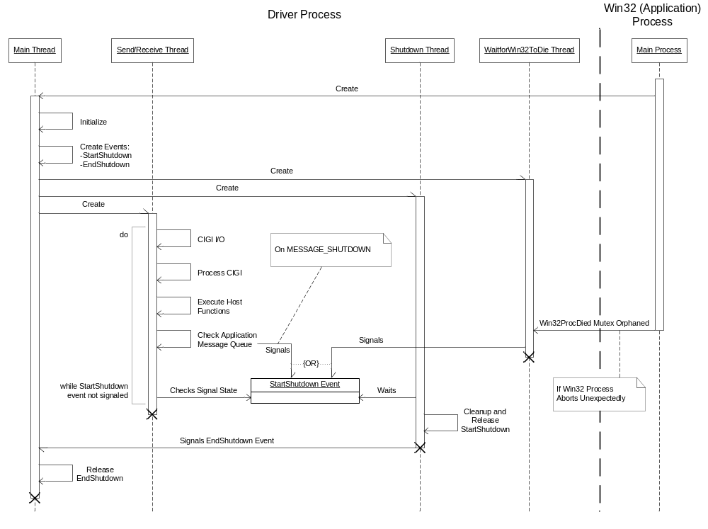
Figure 10. Driver Thread Sequence Diagram
The driver’s Main thread has the lowest priority of the compulsory threads. The Main thread simply calls Startup() and then waits for the EndShutdown event to be signaled. Startup() initializes the coordinate conversion library, the CIGI API, the message queues, and the sockets. Startup() also creates the BeginShutdown and EndShutdown events and the remaining compulsory threads.
The Send/Receive thread is the primary worker thread and has the highest priority of all the driver’s threads. This thread handles network I/O and updates the entity, view, view group, and mission function objects. This thread also performs message processing for Win32-to-Driver messages (see Section 5.1.3.2). The Send/Receive thread executes in a loop until the StartShutdown event is signaled.
The Shutdown thread simply waits for the StartShutdown event to be signaled. When the event is signaled, the Shutdown thread performs cleanup tasks and signals the EndShutdown event.
Finally, the WaitForWin32ToDie thread waits for the main Win32 application process to terminate abnormally. To do this the thread waits indefinitely on a mutex. If the application process does terminate abnormally, the mutex will be orphaned and thus the WaitForWin32ToDie thread can resume execution. The thread will then signal the StartShutdown event.
Two additional threads, Record and Read, are low-priority threads that are used for buffered disk I/O during recording and playback of CIGI messages. These threads are created by the Send/Receive thread as needed.
The following table lists the priorities of each of the driver’s threads:
Table 5. Driver Thread Priorities
Thread | Priority (RTX) | Priority (Win32)
Main | RT_PRIORITY_MIN + 2 | THREAD_PRIORITY_NORMAL
Send/Receive | RT_PRIORITY_MAX | THREAD_PRIORITY_ABOVE_NORMAL
Shutdown | RT_PRIORITY_MIN + 3 | THREAD_PRIORITY_NORMAL
WaitForWin32ToDie | RT_PRIORITY_MIN + 4 | THREAD_PRIORITY_NORMAL
Read | RT_PRIORITY_MIN | THREAD_PRIORITY_BELOW_NORMAL
Record | RT_PRIORITY_MIN | THREAD_PRIORITY_BELOW_NORMAL

The lowest priority level available in the RTX subsystem is RT_PRIORITY_MIN. Because they handle disk I/O, both the Read and Record threads are set to this priority level. These threads are mutually exclusive so they will never be created at the same time; therefore, they will never be competing for resources. The other threads are set at different priority levels in RTX to ensure predictable behavior.
Windows has fewer priority levels than RTX, and the Win32 API exposes only a limited subset for each process priority class. The Main, Send/Receive, and WaitForWin32ToDie threads are all given the default priority (THREAD_PRIORITY_NORMAL). This is acceptable given the performance limitations of Windows for real-time applications.
Note that on a single- or dual-CPU computer running Windows 2000 and Windows XP, using the THREAD_PRIORITY_TIME_CRITICAL priority level for the Send/Receive thread in the Win32 build does not improve performance from that with the THREAD_PRIORITY_ABOVE_NORMAL priority level. In fact, even on a dual-CPU computer, the performance of the system is diminished when the THREAD_PRIORITY_TIME_CRITICAL priority level is used. More experimentation is needed to determine the optimum priority assignments on a computer with four logical processors (e.g., two CPUs with HyperThreading or two dual-core CPUs).

Main Loop
The driver’s main program loop is executed by the Send/Receive thread. The thread’s entry point is the SendRcvThread() function defined in the HemuRtDrv.cpp file. The sequence diagram in Figure 11 shows the basic program flow of this thread:
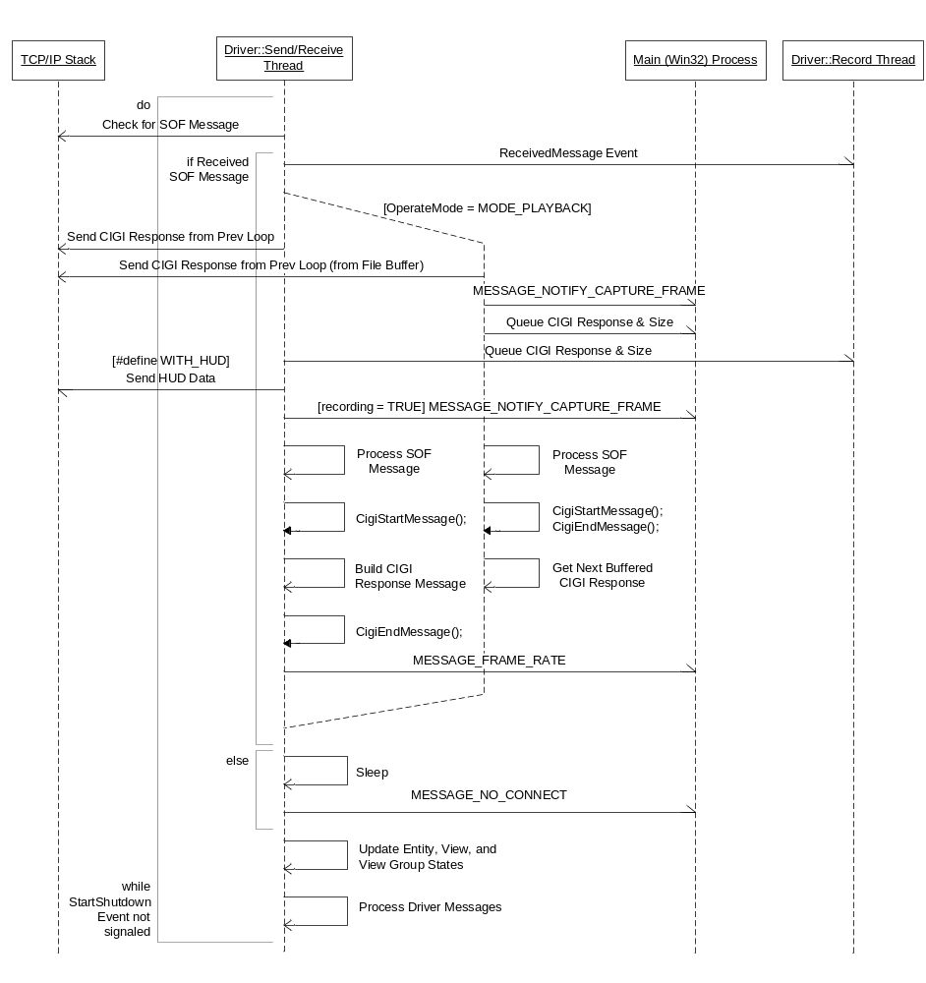
Figure 11. Send/Receive Thread Sequence Diagram
The diagram above includes four objects. Two of driver’s threads are shown: the Send/Receive thread and the Record thread. The TCP/IP stack represents the network interface; interaction with the TCP/IP stack occurs through either the Berkeley Sockets or WinSock API, depending upon the target platform. Finally, the Main Process is the main Win32 application process.
The bulk of the Send/Receive thread is contained within a do-while loop. This loop executes until the StartShutdown event is signaled.
The first thing the Send/Receive thread does inside the loop is check the TCP/IP stack for a CIGI SOF (Start of Frame) message from the IG. If a message is received, then the thread will send the response message created during the previous frame and will then process the SOF message. If no SOF message is received, the thread will sleep for a short time and send a MESSAGE_NO_CONNECT message to the Win32 process.
When processing the SOF message, there are two possible paths of execution. If the driver is in Playback mode (OperateMode = MODE_PLAYBACK), then the CIGI response message will have been retrieved from the file buffer during the prior frame. A MESSAGE_NOTIFY_CAPTURE_FRAME message will then be sent to the Win32 process as a progress notification. The thread will then queue a copy of the response message (and the corresponding message size) to the Win32 process, process the received SOF message, and build the response message for the next successive frame. To build the message, the driver must call CigiBeginMessage() and CigiEndMessage() even though no packets will be explicitly added to the message. The message is instead populated from the contents of the playback (file) buffer.
If the driver is not in Playback mode, the other path is executed. The CIGI response message will have been build packet by packet during the prior frame. If a Record thread has been created, then the Send/Receive thread will place a copy of the response message in the record (file) buffer and will send a MESSAGE_NOTIFY_CAPTURE_FRAME message to the Win32 process. The Send/Receive thread will then process the SOF message and build the CIGI response message for the next frame.
After the conditional branch, after the CIGI messages have been processed and created, the Send/Receive thread will visit each entity, view, and view group and update their states. The thread will then process any messages on the Win32-to-Driver inter-process message queue (see Section 5.1.3.1). The loop will then start again.

Buffered Record and Playback
Record and playback of CIGI messages is handled by low-priority worker theads that read CIGI messages from a Record/Playback buffer and write them to disk, or vice versa. The buffer is actually a queue of type RTXSharedBufferQ (see Section 5.1.3.1 for details on this class). The queue maintains a circular array of buffers and the size of each CIGI message.
When the Rend/Receive thread handles a MESSAGE_BEGIN_RECORD message from the main process, the thread will call the StartRecord() function. This function opens the specified file for writing, creates the StartRecordShutdown and EndRecordShutdown events, and creates a low-priority Record thread.
The Send/Receive thread will store a copy of all outgoing CIGI messages in the Record/Playback buffer. The Record thread continually polls the Record/Playback queue and writes any CIGI messages to the file.
When the Send/Receive thread receives a MESSAGE_END_RECORD message, the Send/Receive thread will signal the StartRecordShutdown event. The Record thread will then signal the EndRecordShutdown event and terminate.
Playback of CIGI messages works similarly. A MESSAGE_BEGIN_PLAYBACK message will cause the Send/Receive thread to call StartPlayback(). This function opens the specified file for reading, creates the StartRecordShutdown and EndRecordShutdown events, sets the OperateMode flag to MODE_PLAYBACK, and creates a low-priority Read thread.
Note that the StartRecordShutdown and EndRecordShutdown events are used for both recording and playback. This is acceptable because execution of the Record and Read threads is mutually exclusive. In fact, both event objects were originally intended to be used with both threads; however, the word “Playback” was omitted from the event names to keep them short.
Once created, the Read thread will continually try to keep the Record/Playback buffer completely full with CIGI messages read from disk. Because the OperateMode flag is set to MODE_PLAYBACK, the Send/Receive thread will retrieve its next CIGI message from the buffer each frame.
When the Send/Receive thread receives a MESSAGE_END_PLAYBACK message it will set the EndRecordShutdown event. The Read thread will then set OperateMode to MODE_NORMAL and terminate.

RTX API Façade
For Win32 builds of the Host Emulator, a façade API has been created which implements a subset of the RTX API functions using the Win32 API. Most of the RTX functions have a direct Win32 analog and so the façade simply calls the corresponding Win32 function. Other façade functions implement similar functionality by using the mechanisms provided by the Win32 API.
Two functions in this façade, however, do not duplicate or simulate the behavior of the RTX functions with the same names. These functions are RtGetClockTimerPeriod() and RtGetClockResolution().
The RTX implementation of RtGetClockTimerPeriod() returns the period of one of the specified RTSS system clocks. The façade implementation actually calls QueryPerformanceFrequency(), which retrieves the frequency of Windows’ high-performance counter. The RTX implementation has no effect on the Host Emulator since the driver does not use the function’s return value.
The RTX version of RtGetClockResolution() returns the resolution of the specified RTSS clock. The façade implementation sets a module-level flag to force RtSleepFt() to truncate rather than round the value passed to it. The use of this façade is questionable since the façade’s behavior has nothing to do with that of the original function; however, the reuse of this function name is convenient because it already exists in the namespace of the RTX build and because the function is not otherwise called from within the Host Emulator.
Note: The RtGetClockTimerPeriod() and RtGetClockResolution() façades will be replaced with more appropriately named functions in a future release.

Abandoned Designs
Two approaches to the problem of non-blocking, synchronized access to shared data have been implemented in earlier versions of the Host Emulator. Both approaches had inherent problems and were abandoned. Both of these are documented in this section as lessons learned.

Unsynchronized Data Access
Version 2.x of the Host Emulator did not use any thread-level synchronization mechanisms for data access. This meant that one or more threads could be writing to an object’s data while another was reading it. Most of the time this caused no serious problems, as the GUI enforced data concurrency by forcing the user to “freeze” the simulation to modify an entity’s state data. However, many users requested the ability to change and entity’s state “on the fly,” requiring the need to add more sophisticated synchronization mechanisms.

Asynchronous Object Creation and Write
Versions 3.0.0 through 3.1.2 of the Host Emulator limited object creation and data write operations to the driver’s primary thread. Read operations were unsynchronized and could be performed by any thread within either process.
When a new object needed to be created, the main process would send a message to the driver containing the object name, ID, and possibly some initial data. At some point during its main loop, the driver would process the message and create the object. The main process would sleep for a short amount of time or, in later versions, wait for a creation acknowledgement message from the driver. The main process would then be free to act upon the object.
Writes were also performed only by the driver. The main process would send a message to the driver containing all the object state data. The driver’s primary thread would process the message and update the object.
The above approach worked satisfactorily for user interaction through the GUI. The wait time or latency after a user action occurred was minimal and was generally not noticeable.
Unfortunately, asynchronous creation and writes broke down during the execution of scripts. The script processor thread is designed to execute as many lines as possible until one of the wait commands is encountered or until the outgoing message buffer is full. The thread, therefore, does not have time to sleep or to wait for the acknowledgement message from the driver. Requiring the script thread to wait or sleep would cause scripts to run slowly because the thread would have to wait at least one frame between commands that act upon the same object. The listing below shows a sample script snippet and the implicit waits that would be produced by asynchronous writes:
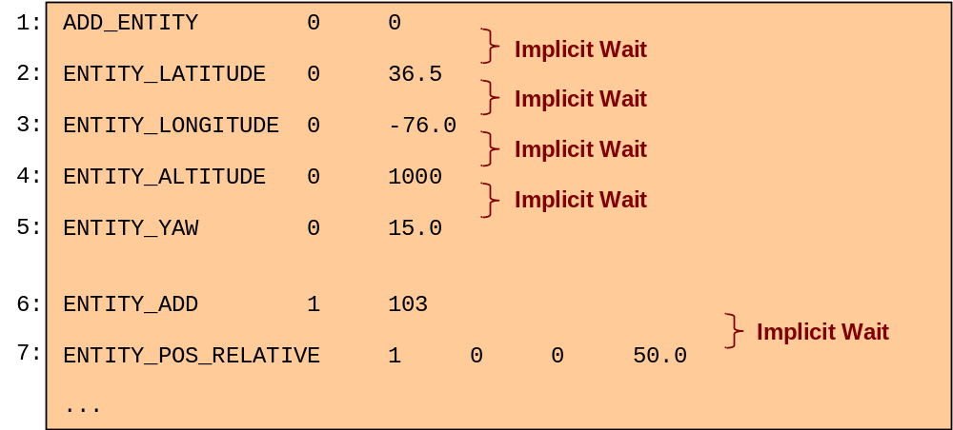
Listing 2. Example Script with Implicit Waits
Removing the waits would cause data concurrency problems. Using the example in Listing 2 above, the script processor would execute Line 1 and would send a message to the driver. The script processor would then immediately execute Line 2; however, the driver would likely not have time to process the message and create the entity so Line 2, as well as Lines 3 through 5, would be acting upon a non-existent entity.
Assuming the entity had been created successfully, the script processor would process Line 2, the entity’s state would be read, and a message would be sent to the driver to update the entity’s position with the new latitude. The script processor would then immediately process Line 3, and the entity’s state would be read once more. Again, the driver would likely not have time to process the message containing the new latitude, so the data read would contain the previous latitude. This
Because neither the implicit waits nor the lack of data concurrency were acceptable, the asynchronous data access mechanism was circumvented. The shared object classes were subclassed and the accessor methods overridden to allow the script processor direct access to the shared memory. Unfortunately, this reintroduced the problems inherent with the unsynchronized architecture described in Section 6.1 and caused additional errors.

Acronyms
CIGI – Common Image Generator Interface
GDI – Graphics Device Interface
GUI – Graphical User Interface
HAT – Height Above Terrain
HOT – Height of Terrain
IG – Image Generator
IPC – Inter-Process Communication
LOS – Line of Sight
RTSS – Real-Time Subsystem (the RTX runtime environment)
SOF – Start of Frame
UML – Unified Modeling Language

